# GRUPO 3 - DOCUMENTO SPRINT 3

## Interfaces graficas de página Web

### Página Principal

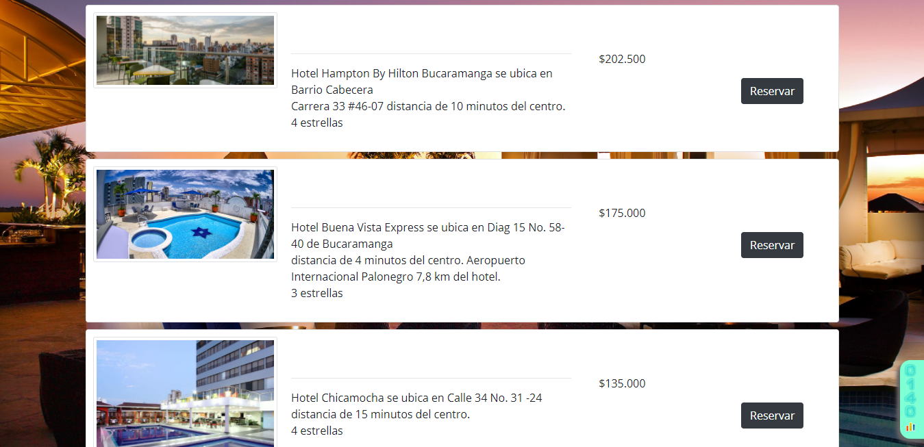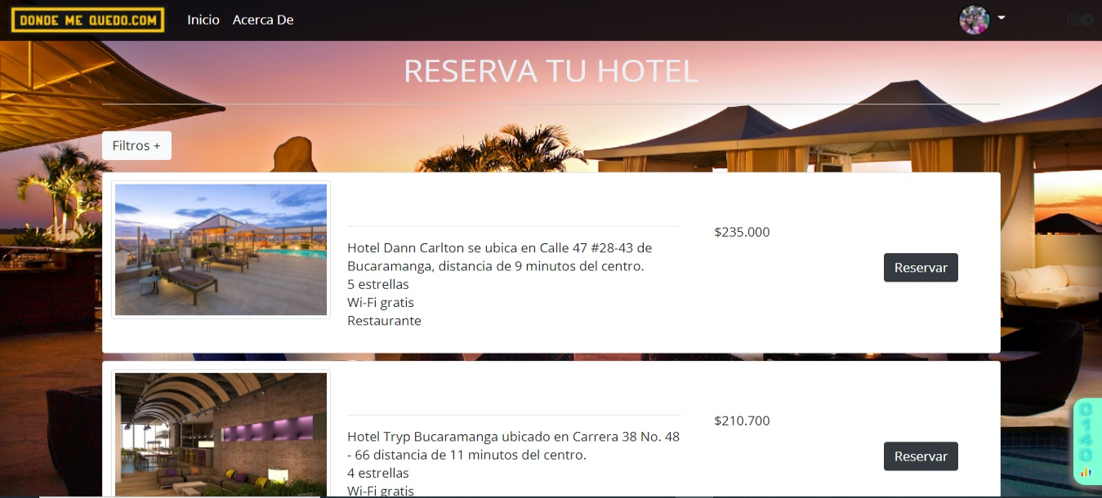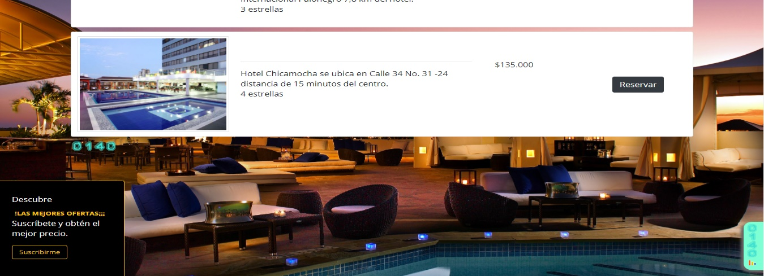

### Página de Registro

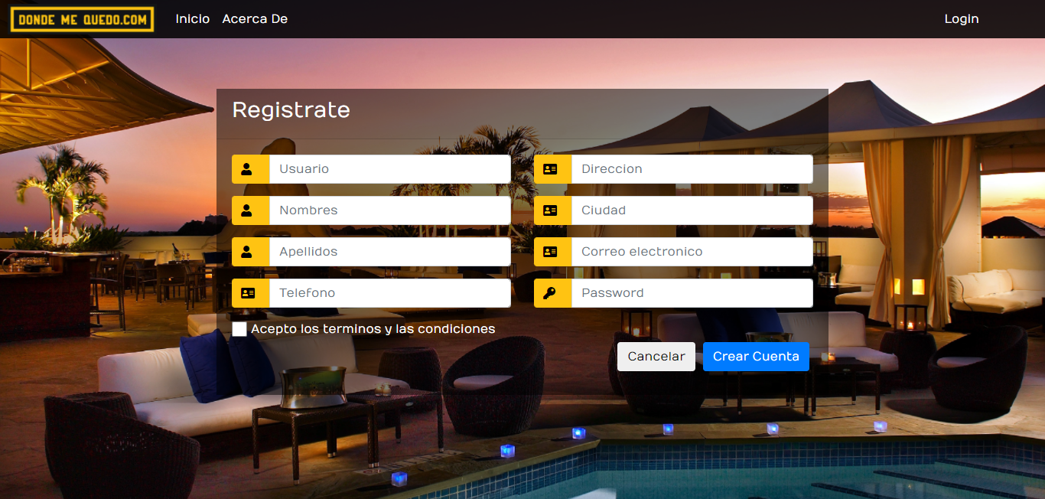

### Página de Login

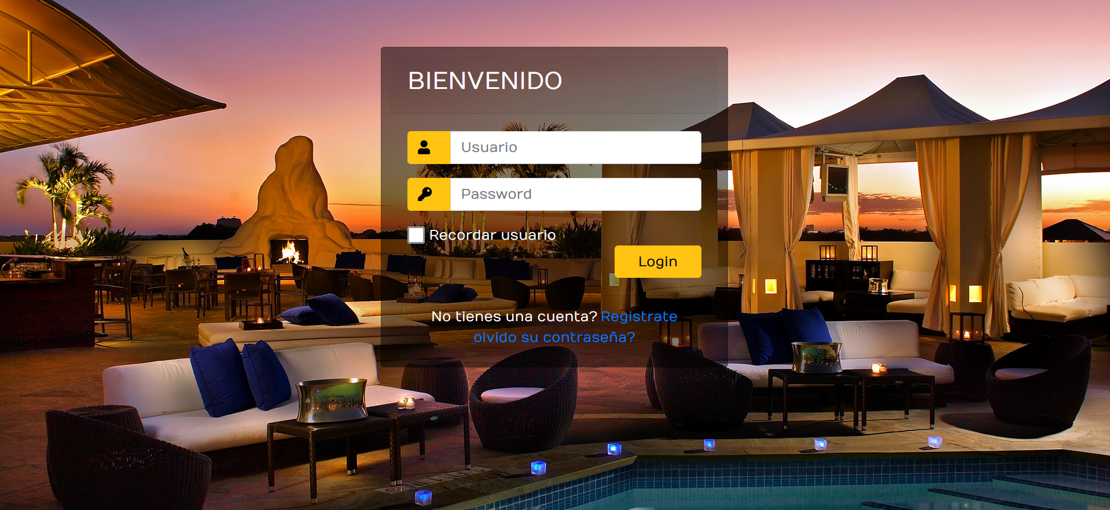

### Página de Pagos

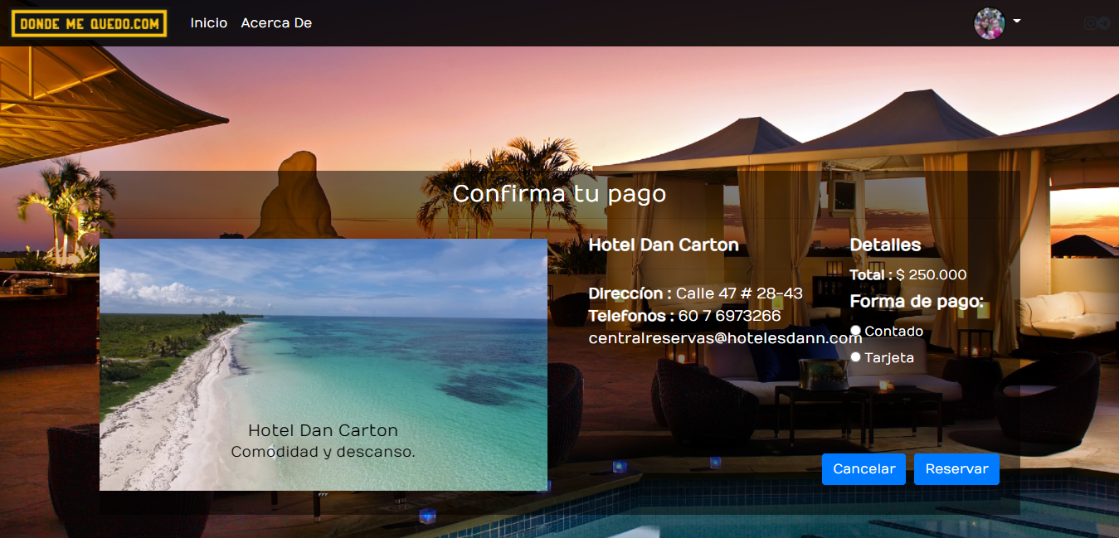

### Página de Perfil

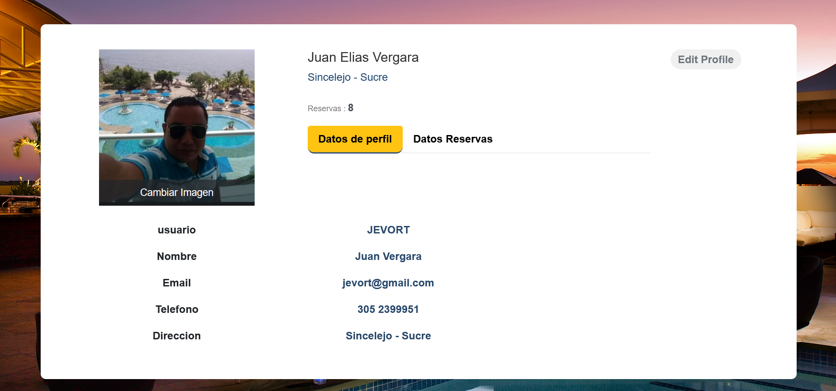

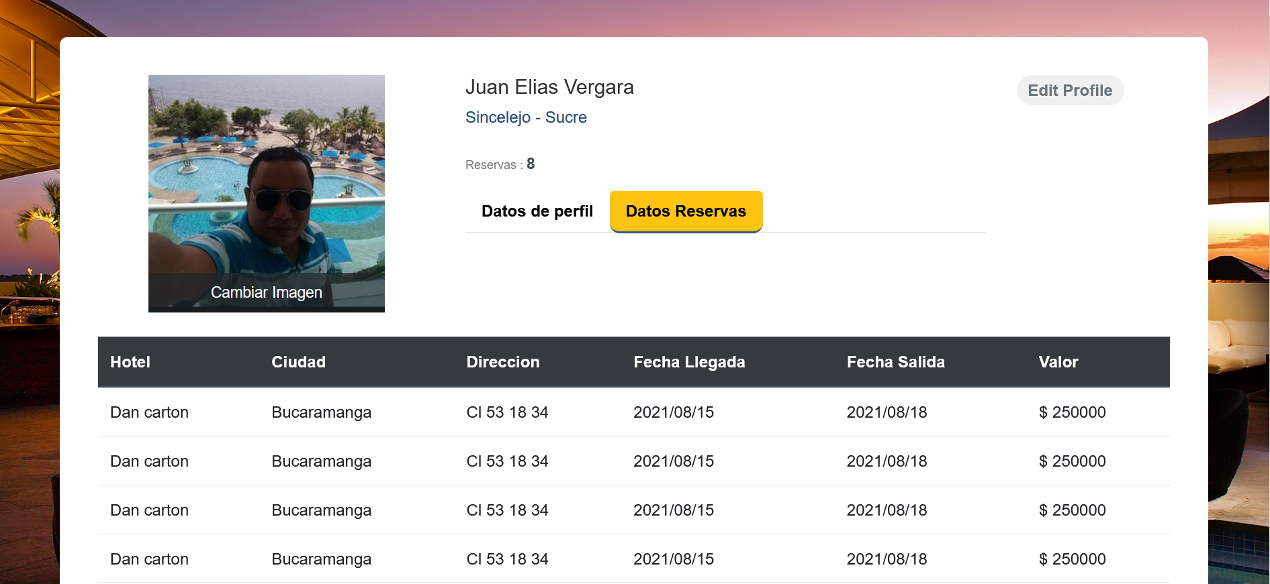

## Estructura de repositorio

A continuación se relaciona la estructura de repositorio “proyectowebteam3”:

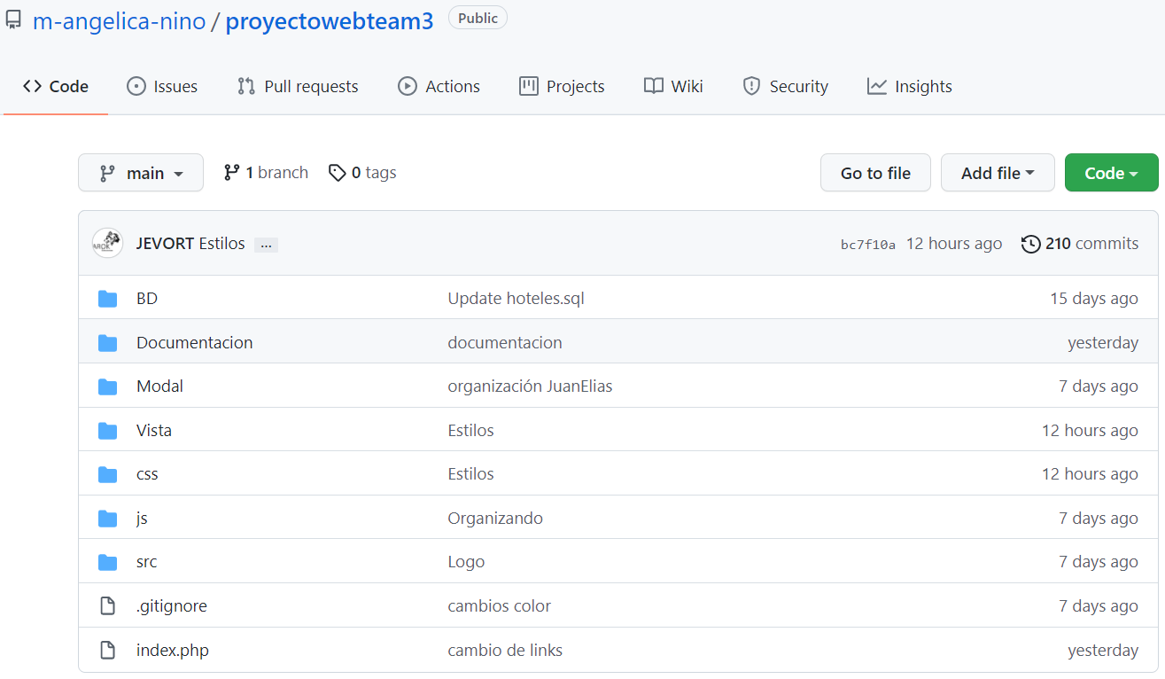

## Estructura HTML de las interfaces

### HTML – Página Principal

<!DOCTYPE html>

<html lang="es">

<head>

  <meta charset="UTF-8" />

  <meta name="viewport" content="width=device-width, user-scalable=no, initial-scale=1.0, maximum-scale=1.0, minimum-scale=1.0" />

  <title>Donde me quedo.com</title>

  <link rel="stylesheet" href="https://stackpath.bootstrapcdn.com/bootstrap/4.3.1/css/bootstrap.min.css" integrity="sha384-ggOyR0iXCbMQv3Xipma34MD+dH/1fQ784/j6cY/iJTQUOhcWr7x9JvoRxT2MZw1T" crossorigin="anonymous" />

  <link rel="stylesheet" href="../css/estilos.css" />

  <link rel="stylesheet" href="../css/estilosprincipal.css" />

  <link href="https://fonts.googleapis.com/css?family=Open+Sans:400,600,700" rel="stylesheet" />

</head>

<body>

  <?php

  include_once('plantillanav.php');

  ?>

  <div class="wrap">

    <h1>RESERVA TU HOTEL</h1>

    <section class="">

      <p>

        <button class="btn btn-light " ; type="button" data-toggle="collapse" data-target="#collapseExample" aria-expanded="false" aria-controls="collapseExample">

          Filtros +

        </button>

      </p>

      <div class="collapse" id="collapseExample">

        <div class="card card-body">

          <!---FORMULARIO DE FILTROS -->

          <br>

          <form>

            <div class="form-row">

              <div class="form-group col-md-8">

                <div class="form-row">

                  <div class="form-group col-md-5">

                    <label for="inputCity">Ciudad</label>

                    <input type="text" class="form-control" id="inputCity" placeholder="Sincelejo" />

                  </div>

                  <div class="form-group col-md-3">

                    <label for="inputState">Tipo de Habitación</label>

                    <select id="inputState" class="form-control">

                      <option selected>Suit</option>

                      <option>Doble</option>

                      <option>Sencilla</option>

                    </select>

                  </div>

                  <div class="form-group col-md-2">

                    <label for="inputZip">N° Personas</label>

                    <input type="number" value="2" min="1" max="8" class="form-control" />

                  </div>

                </div>

                <!-- -->

                <div class="form-row">

                  <div class="form-group col-md-5">

                    <label for="inputCity">Rango De Precios</label>

                    <div class="input-group mb-3">

                      <div class="input-group-prepend">

                        <span class="input-group-text">$</span>

                      </div>

                      <input type="number" value="125000" min="1" max="1000000" class="form-control" aria-label="Amount (to the nearest dollar)">

                      <div class="input-group-append">

                      </div>

                    </div>

                  </div>

                  <div class="form-group col-md-3">

                    <label for="inputZip">Fecha Entrada</label>

                    <input type="date" class="form-control" id="inputZip" placeholder="2021/09/01" />

                  </div>

                  <div class="form-group col-md-3">

                    <label for="inputZip">Fecha Salida</label>

                    <input type="date" class="form-control" id="inputZip" placeholder="2021/09/15" />

                  </div>

                </div>

              </div>

              <div class="form-group col-md-3">

                <br>

                <div class="form-group">

                  <div class="form-check">

                    <input class="form-check-input" type="checkbox" id="ParqueaderoCheck" name="ParqueaderoCheck" />

                    <label class="form-check-label" for="ParqueaderoCheck">

                      Parqueadero

                    </label>

                  </div>

                </div>

                <div class="form-group">

                  <div class="form-check">

                    <input class="form-check-input" type="checkbox" id="desayunoCheck" name="desayunoCheck" />

                    <label class="form-check-label" for="desayunoCheck">

                      Desayuno

                    </label>

                  </div>

                </div>

                <div class="form-group">

                  <div class="form-check">

                    <input class="form-check-input" type="checkbox" id="piscinaCheck" name="piscinaCheck" />

                    <label class="form-check-label" for="piscinaCheck">

                      Piscina

                    </label>

                  </div>

                </div>

              </div>

            </div>

            <button type="submit" class="btn btn-warning alin">

              Filtrar

            </button>

          </form>

        </div>

      </div>

    </section>

    <div class="store-wrapper">

      <section class="products-list">

        <!-- inicio de seccion de carga-->

        <div class="card" style="width: 100%">

          <div class="row no-gutters">

            <div class="col-sm-3">

              <img class="card-img tam img-thumbnail"  src="../src/images/danncarlton.jpeg" alt="Suresh Dasari Card" />

            </div>

            <div class="col-sm-5">

              <div class="card-body">

                <h5 class="card-title">Hotel Dann Carlton </h5>

                <hr />

                <p class="card-text">

                  Hotel Dann Carlton se ubica en Calle 47 #28-43 de Bucaramanga, distancia de 9 minutos del centro. <br>

                  5 estrellas <br>

                  Wi-Fi gratis <br>

                  Restaurante <br>

                </p>

              </div>

            </div>

            <div class="col-sm-4">

              <div class="card-body">

                <h5 class="card-title"> Precios</h5>

                <p class="card-text">

                  $235.000

                </p>

                <a href="#" class="btn btn-dark alin">Reservar</a>

              </div>

            </div>

          </div>

        </div>

        <div class="card" style="width: 100%">

          <div class="row no-gutters">

            <div class="col-sm-3">

              <img class="card-img tam img-thumbnail" src="../src/images/tryp.jpg" alt="Suresh Dasari Card" />

            </div>

            <div class="col-sm-5">

              <div class="card-body">

                <h5 class="card-title">Tryp</h5>

                <hr />

                <p class="card-text">

                  Hotel Tryp Bucaramanga ubicado en Carrera 38 No. 48 - 66 distancia de 11 minutos del centro. <br>

                  4 estrellas <br>

                  Wi-Fi gratis <br>

                  Restaurante <br>

                </p>

              </div>

            </div>

            <div class="col-sm-4">

              <div class="card-body">

                <h5 class="card-title">Precios</h5>

                <p class="card-text">

                  $210.700

                </p>

                <a href="#" class="btn btn-dark alin">Reservar</a>

              </div>

            </div>

          </div>

        </div>

        <div class="card" style="width: 100%">

          <div class="row no-gutters">

            <div class="col-sm-3">

              <img class="card-img tam img-thumbnail" src="../src/images/hampton.jpg"  class="rounded mx-auto d-block" alt="Suresh Dasari Card" />

            </div>

            <div class="col-sm-5">

              <div class="card-body">

                <h5 class="card-title">Hampton by Hilton</h5>

                <hr />

                <p class="card-text">

                  Hotel Hampton By Hilton Bucaramanga se ubica en Barrio Cabecera <br>

                  Carrera 33 #46-07 distancia de 10 minutos del centro. <br>

                  4 estrellas <br>

                </p>

              </div>

            </div>

            <div class="col-sm-4">

              <div class="card-body">

                <h5 class="card-title">Precios</h5>

                <p class="card-text">

                  $202.500

                </p>

                <a href="#" class="btn btn-dark alin">Reservar</a>

              </div>

            </div>

          </div>

        </div>

        <div class="card" style="width: 100%">

          <div class="row no-gutters">

            <div class="col-sm-3">

              <img class="card-img tam img-thumbnail" src="../src/images/buenavista.jpg" alt="Suresh Dasari Card" />

            </div>

            <div class="col-sm-5">

              <div class="card-body">

                <h5 class="card-title">Hotel Buenavista</h5>

                <hr />

                <p class="card-text">

                  Hotel Buena Vista Express se ubica en Diag 15 No. 58-40 de Bucaramanga <br>

                  distancia de 4 minutos del centro. Aeropuerto Internacional Palonegro 7,8 km del hotel.<br>

                  3 estrellas <br>

                </p>

              </div>

            </div>

            <div class="col-sm-4">

              <div class="card-body">

                <h5 class="card-title">Precios</h5>

                <p class="card-text">

                  $175.000

                </p>

                <a href="#" class="btn btn-dark alin">Reservar</a>

              </div>

            </div>

          </div>

        </div>

        <div class="card" style="width: 100%">

          <div class="row no-gutters">

            <div class="col-sm-3">

              <img class="card-img tam img-thumbnail" src="../src/images/chicamocha.jpg" alt="Suresh Dasari Card" />

            </div>

            <div class="col-sm-5">

              <div class="card-body">

                <h5 class="card-title">Hotel Chicamocha</h5>

                <hr />

                <p class="card-text">

                  Hotel Chicamocha se ubica en Calle 34 No. 31 -24 distancia de 15 minutos del centro. <br>

                  4 estrellas <br>

                </p>

              </div>

            </div>

            <div class="col-sm-4">

              <div class="card-body">

                <h5 class="card-title">Precios</h5>

                <p class="card-text">

                  $135.000

                </p>

                <a href="#" class="btn btn-dark alin">Reservar</a>

              </div>

            </div>

          </div>

        </div>

        <div id="sfcztnm42u52y2hdcw64prc52g98t48f51g"></div>

        <img src="https://counter10.stat.ovh/private/contadorvisitasgratis.php?c=ztnm42u52y2hdcw64prc52g98t48f51g" border="0" title="contador de visitas html" alt="contador de visitas html"></a></noscript>

        <!-- fin de seccion de carga-->

      </section>

    </div>

  </div>

  <div class="cardB text-white bg-info mb-4 rounded-top" style="max-width: 15rem;" >

    <div class="card-header">Descubre</div>

    <div class="card-body" >

      <h5 class="cardB-title"><br><br><br><br> !LAS MEJORES OFERTAS¡¡¡</h5>

      <p class="card-text">Suscríbete y obtén el mejor precio.</p>

      <div label for="exampleInputEmail1" class="form-label"></div>

      <a href="#" class="btn Sub_btn sticky">Suscribirme</a>

    </div>

  </div>

  <script src="https://code.jquery.com/jquery-3.3.1.slim.min.js" integrity="sha384-q8i/X+965DzO0rT7abK41JStQIAqVgRVzpbzo5smXKp4YfRvH+8abtTE1Pi6jizo" crossorigin="anonymous"></script>

  <script src="https://cdnjs.cloudflare.com/ajax/libs/popper.js/1.14.7/umd/popper.min.js" integrity="sha384-UO2eT0CpHqdSJQ6hJty5KVphtPhzWj9WO1clHTMGa3JDZwrnQq4sF86dIHNDz0W1" crossorigin="anonymous"></script>

  <script src="https://stackpath.bootstrapcdn.com/bootstrap/4.3.1/js/bootstrap.min.js" integrity="sha384-JjSmVgyd0p3pXB1rRibZUAYoIIy6OrQ6VrjIEaFf/nJGzIxFDsf4x0xIM+B07jRM" crossorigin="anonymous"></script>

  <script src="js/jquery-3.2.1.js"></script>

  <script type="text/javascript" src="https://counter10.stat.ovh/private/counter.js?c=ztnm42u52y2hdcw64prc52g98t48f51g&down=async" async></script>

  <noscript><a href="https://www.contadorvisitasgratis.com" title="contador de visitas html">

</body>

</html>

### HTML - Pagina De Registro

<!DOCTYPE html>

<html lang="es">

<head>

    <meta charset="UTF-8" />

    <meta name="viewport" content="width=device-width, user-scalable=no, initial-scale=1.0, maximum-scale=1.0, minimum-scale=1.0" />

    <link rel="stylesheet" href="https://maxcdn.bootstrapcdn.com/bootstrap/4.0.0/css/bootstrap.min.css" integrity="sha384-Gn5384xqQ1aoWXA+058RXPxPg6fy4IWvTNh0E263XmFcJlSAwiGgFAW/dAiS6JXm" crossorigin="anonymous">

    <link rel="stylesheet" href="https://cdnjs.cloudflare.com/ajax/libs/font-awesome/5.15.4/css/all.min.css">

    <script src="https://code.jquery.com/jquery-3.3.1.slim.min.js" integrity="sha384-q8i/X+965DzO0rT7abK41JStQIAqVgRVzpbzo5smXKp4YfRvH+8abtTE1Pi6jizo" crossorigin="anonymous"></script>

    <script src="https://cdnjs.cloudflare.com/ajax/libs/popper.js/1.14.7/umd/popper.min.js" integrity="sha384-UO2eT0CpHqdSJQ6hJty5KVphtPhzWj9WO1clHTMGa3JDZwrnQq4sF86dIHNDz0W1" crossorigin="anonymous"></script>

    <script src="https://stackpath.bootstrapcdn.com/bootstrap/4.3.1/js/bootstrap.min.js" integrity="sha384-JjSmVgyd0p3pXB1rRibZUAYoIIy6OrQ6VrjIEaFf/nJGzIxFDsf4x0xIM+B07jRM" crossorigin="anonymous"></script>

    <script src="js/jquery-3.2.1.js"></script>

    <script src="js/script.js"></script>

    <title>Registro</title>

    <link rel="stylesheet" href="../css/estilos.css" />

    <link rel="stylesheet" href="../css/estyloslogin.css" />

</head>

<body>

<?php

    include_once 'plantillanavbarregistro.php'

    ?>

    <div class="container">

        <div class="d-flex justify-content-center h-100">

            <div class="card2">

                <div class="card-header">

                    <h3>Registrate </h3>

                    <div class="d-flex justify-content-end social_icon">

                        <span><i></i></span>

                        <span><i></i></span>

                        <span><i></i></span>

                    </div>

                </div>

                <div class="card-body">

                    <form>

                        <div class="row">

                            <div class="col-md-6">

                                <div class="input-group form-group">

                                    <div class="input-group-prepend">

                                        <span class="input-group-text"><i class="fas fa-user"></i></span>

                                    </div>

                                    <input autocomplete="off" type="text" class="form-control" placeholder="Usuario">

                                </div>

                                <div class="input-group form-group">

                                    <div class="input-group-prepend">

                                        <span class="input-group-text"><i class="fas fa-user"></i></span>

                                    </div>

                                    <input autocomplete="off" type="text" class="form-control" placeholder="Nombres">

                                </div>

                                <div class="input-group form-group">

                                    <div class="input-group-prepend">

                                        <span class="input-group-text"><i class="fas fa-user"></i></span>

                                    </div>

                                    <input autocomplete="off" type="text" class="form-control" placeholder="Apellidos">

                                </div>

                                <div class="input-group form-group">

                                    <div class="input-group-prepend">

                                        <span class="input-group-text"><i class="fas fa-address-card"></i></span>

                                    </div>

                                    <input autocomplete="off" type="number" class="form-control" placeholder="Telefono">

                                </div>

                            </div>

                            <div class="col-md-6">

                            <div class="input-group form-group">

                            <div class="input-group-prepend">

                                <span class="input-group-text"><i class="fas fa-address-card"></i></span>

                            </div>

                            <input autocomplete="off" type="text" class="form-control" placeholder="Direccion">

                        </div>

                        <div class="input-group form-group">

                            <div class="input-group-prepend">

                                <span class="input-group-text"><i class="fas fa-address-card"></i></span>

                            </div>

                            <input autocomplete="off" type="text" class="form-control" placeholder="Ciudad">

                        </div>

                        <div class="input-group form-group">

                            <div class="input-group-prepend">

                                <span class="input-group-text"><i class="fas fa-address-card"></i></span>

                            </div>

                            <input autocomplete="off" type="email" class="form-control" placeholder="Correo electronico">

                        </div>

                        <div class="input-group form-group">

                            <div class="input-group-prepend">

                                <span class="input-group-text"><i class="fas fa-key"></i></span>

                            </div>

                            <input autocomplete="new-password" type="password" class="form-control" placeholder="Password">

                        </div>

                            </div>

                        </div>

                        <div class="row align-items-center remember">

                            <input type="checkbox">Acepto los terminos y las condiciones

                        </div>

                        <button type="submit" class="btn btn-primary flotar-der">Crear Cuenta</button>

                        <button type="submit" class="btn btn-secundary flotar-der">Cancelar</button>

                    </form>

                </div>

            </div>

        </div>

    </div>

    <!-- <script src="https://cdn.jsdelivr.net/npm/bootstrap@5.1.1/dist/js/bootstrap.bundle.min.js" integrity="sha384-/bQdsTh/da6pkI1MST/rWKFNjaCP5gBSY4sEBT38Q/9RBh9AH40zEOg7Hlq2THRZ" crossorigin="anonymous"></script> -->

    <script src="https://code.jquery.com/jquery-3.2.1.slim.min.js" integrity="sha384-KJ3o2DKtIkvYIK3UENzmM7KCkRr/rE9/Qpg6aAZGJwFDMVNA/GpGFF93hXpG5KkN" crossorigin="anonymous"></script>

    <script src="https://cdnjs.cloudflare.com/ajax/libs/popper.js/1.12.9/umd/popper.min.js" integrity="sha384-ApNbgh9B+Y1QKtv3Rn7W3mgPxhU9K/ScQsAP7hUibX39j7fakFPskvXusvfa0b4Q" crossorigin="anonymous"></script>

    <script src="https://maxcdn.bootstrapcdn.com/bootstrap/4.0.0/js/bootstrap.min.js" integrity="sha384-JZR6Spejh4U02d8jOt6vLEHfe/JQGiRRSQQxSfFWpi1MquVdAyjUar5+76PVCmYl" crossorigin="anonymous"></script>

</body>

</html>

### HTML - Recuperación Password

<!DOCTYPE html>

<html lang="es">

<head>

<meta charset="UTF-8" />

    <meta name="viewport" content="width=device-width, user-scalable=no, initial-scale=1.0, maximum-scale=1.0, minimum-scale=1.0" />

    <title>Donde Me Quedo</title>

    <link rel="stylesheet" href="https://stackpath.bootstrapcdn.com/bootstrap/4.3.1/css/bootstrap.min.css" integrity="sha384-ggOyR0iXCbMQv3Xipma34MD+dH/1fQ784/j6cY/iJTQUOhcWr7x9JvoRxT2MZw1T" crossorigin="anonymous" />

    <link rel="stylesheet" href="https://cdnjs.cloudflare.com/ajax/libs/font-awesome/5.15.4/css/all.min.css">

    <link rel="stylesheet" href="../css/estilos.css" />

    <link rel="stylesheet" href="../css/estyloslogin.css" />

    <link href="https://fonts.googleapis.com/css?family=Open+Sans:400,600,700" rel="stylesheet" />

    <script src="https://code.jquery.com/jquery-3.3.1.slim.min.js" integrity="sha384-q8i/X+965DzO0rT7abK41JStQIAqVgRVzpbzo5smXKp4YfRvH+8abtTE1Pi6jizo" crossorigin="anonymous"></script>

    <script src="https://cdnjs.cloudflare.com/ajax/libs/popper.js/1.14.7/umd/popper.min.js" integrity="sha384-UO2eT0CpHqdSJQ6hJty5KVphtPhzWj9WO1clHTMGa3JDZwrnQq4sF86dIHNDz0W1" crossorigin="anonymous"></script>

    <script src="https://stackpath.bootstrapcdn.com/bootstrap/4.3.1/js/bootstrap.min.js" integrity="sha384-JjSmVgyd0p3pXB1rRibZUAYoIIy6OrQ6VrjIEaFf/nJGzIxFDsf4x0xIM+B07jRM" crossorigin="anonymous"></script>

    <script src="js/jquery-3.2.1.js"></script>

    <script src="js/script.js"></script>

</head>

<body>

<?php

    include_once 'plantillanavbarregistro.php'

    ?>

    <div class="container">

        <div class="d-flex justify-content-center h-100">

            <div class="card2">

                <div class="card-header">

                    <h3>Recuperar Contraseña</h3>

                    <div class="d-flex justify-content-end social_icon">

                        <span><i ></i></span>

                        <span><i ></i></span>

                        <span><i ></i></span>

                    </div>

                </div>

                <div class="card-body">

                    <form>

                    <p class="links">Ingresa tu usuario</p>

                        <div class="input-group form-group">

                            <div class="input-group-prepend">

                                <span class="input-group-text"><i class="fas fa-user"></i></span>

                            </div>

                            <input autocomplete="off" type="text" class="form-control" placeholder="Usuario">

                        </div>

                        <p class="links">Ingresa tu correo electronico</p>

                        <div class="input-group form-group">

                            <div class="input-group-prepend">

                                <span class="input-group-text"><i class="fas fa-address-card"></i></span>

                            </div>

                            <input autocomplete="off" type="email" class="form-control" placeholder="Correo electronico">

                        </div>

                        <p class="links">Se enviara un mensaje a tu correo electronico para recuperar tu contraseña</p>

                        <div >

                            <input type="submit" value="Enviar Correo" class="btn float-left login_btn2">

                        </div>

                    </form>

                </div>

                <div class="card-footer">

                </div>

            </div>

        </div>

    </div>

    <!-- <script src="https://cdn.jsdelivr.net/npm/bootstrap@5.1.1/dist/js/bootstrap.bundle.min.js" integrity="sha384-/bQdsTh/da6pkI1MST/rWKFNjaCP5gBSY4sEBT38Q/9RBh9AH40zEOg7Hlq2THRZ" crossorigin="anonymous"></script> -->

    <script src="https://code.jquery.com/jquery-3.2.1.slim.min.js" integrity="sha384-KJ3o2DKtIkvYIK3UENzmM7KCkRr/rE9/Qpg6aAZGJwFDMVNA/GpGFF93hXpG5KkN" crossorigin="anonymous"></script>

<script src="https://cdnjs.cloudflare.com/ajax/libs/popper.js/1.12.9/umd/popper.min.js" integrity="sha384-ApNbgh9B+Y1QKtv3Rn7W3mgPxhU9K/ScQsAP7hUibX39j7fakFPskvXusvfa0b4Q" crossorigin="anonymous"></script>

<script src="https://maxcdn.bootstrapcdn.com/bootstrap/4.0.0/js/bootstrap.min.js" integrity="sha384-JZR6Spejh4U02d8jOt6vLEHfe/JQGiRRSQQxSfFWpi1MquVdAyjUar5+76PVCmYl" crossorigin="anonymous"></script>

</body>

</html>

### HTML - Perfil

<!DOCTYPE html>

<html lang="es">

<head>

    <meta charset="UTF-8">

    <meta http-equiv="X-UA-Compatible" content="IE=edge">

    <meta name="viewport" content="width=device-width, initial-scale=1.0">

    <link href="//maxcdn.bootstrapcdn.com/bootstrap/4.1.1/css/bootstrap.min.css" rel="stylesheet" id="bootstrap-css">

    <script src="//maxcdn.bootstrapcdn.com/bootstrap/4.1.1/js/bootstrap.min.js"></script>

    <script src="//cdnjs.cloudflare.com/ajax/libs/jquery/3.2.1/jquery.min.js"></script>

    <title>Perfil</title>

    <link rel="stylesheet" href="https://stackpath.bootstrapcdn.com/bootstrap/4.3.1/css/bootstrap.min.css" integrity="sha384-ggOyR0iXCbMQv3Xipma34MD+dH/1fQ784/j6cY/iJTQUOhcWr7x9JvoRxT2MZw1T" crossorigin="anonymous" />

    <link rel="stylesheet" href="../css/estilos.css" />

    <link rel="stylesheet" href="../css/estilos-perfil.css" />

</head>

<body>

<?php

    include_once 'plantillanav.php'

    ?>

    <div class="container emp-profile">

        <form method="post">

            <div class="row">

                <div class="col-md-4">

                    <div class="profile-img">

                        <img src="../src/imgUsuarios/Juan_Elias.jpeg" alt="" />

                        <div class="file btn btn-lg btn-primary">

                            Cambiar Imagen

                            <input type="file" name="img-perfil" />

                        </div>

                    </div>

                </div>

                <div class="col-md-6">

                    <div class="profile-head">

                        <h5>

                            Juan Elias Vergara

                        </h5>

                        <h6>

                            Sincelejo - Sucre

                        </h6>

                        <p class="proile-rating">Reservas : <span>8</span></p>

                        <ul class="nav nav-tabs" id="myTab" role="tablist">

                            <li class="nav-item">

                                <a class="nav-link title active" id="home-tab" data-toggle="tab" href="#home" role="tab" aria-controls="home" aria-selected="true">Datos de perfil</a>

                            </li>

                            <li class="nav-item">

                                <a class="nav-link title" id="profile-tab" data-toggle="tab" href="#profile" role="tab" aria-controls="profile" aria-selected="false">Datos Reservas</a>

                            </li>

                        </ul>

                    </div>

                </div>

                <div class="col-md-2">

                    <input type="submit" class="profile-edit-btn" name="btnAddMore" value="Edit Profile" />

                </div>

            </div>

            <div class="row">

                <div class="col-md-12">

                    <div class="tab-content profile-tab" id="myTabContent">

                        <div class="tab-pane fade show active centrar" id="home" role="tabpanel" aria-labelledby="home-tab">

                            <div class="row">

                                <div class="col-md-4">

                                    <label>usuario</label>

                                </div>

                                <div class="col-md-3">

                                    <p>JEVORT</p>

                                </div>

                            </div>

                            <div class="row">

                                <div class="col-md-4">

                                    <label>Nombre</label>

                                </div>

                                <div class="col-md-3">

                                    <p>Juan Vergara</p>

                                </div>

                            </div>

                            <div class="row">

                                <div class="col-md-4">

                                    <label>Email</label>

                                </div>

                                <div class="col-md-3">

                                    <p>jevort@gmail.com</p>

                                </div>

                            </div>

                            <div class="row">

                                <div class="col-md-4">

                                    <label>Telefono</label>

                                </div>

                                <div class="col-md-3">

                                    <p>305 2399951</p>

                                </div>

                            </div>

                            <div class="row">

                                <div class="col-md-4">

                                    <label>Direccion</label>

                                </div>

                                <div class="col-md-3">

                                    <p>Sincelejo - Sucre</p>

                                </div>

                            </div>

                        </div>

                        <div class="tab-pane fade" id="profile" role="tabpanel" aria-labelledby="profile-tab">

                            <table class="table">

                                <thead class="thead-dark">

                                    <tr>

                                        <th scope="col">Hotel</th>

                                        <th scope="col">Ciudad</th>

                                        <th scope="col">Direccion</th>

                                        <th scope="col">Fecha Llegada</th>

                                        <th scope="col">Fecha Salida</th>

                                        <th scope="col">Valor</th>

                                    </tr>

                                </thead>

                                <tbody>

                                    <tr>

                                        <td>Dan carton</td>

                                        <td>Bucaramanga</td>

                                        <td>Cl 53 18 34</td>

                                        <td>2021/08/15</td>

                                        <td>2021/08/18</td>

                                        <td>$ 250000</td>

                                    </tr>

                                    <tr>

                                        <td>Dan carton</td>

                                        <td>Bucaramanga</td>

                                        <td>Cl 53 18 34</td>

                                        <td>2021/08/15</td>

                                        <td>2021/08/18</td>

                                        <td>$ 250000</td>

                                    </tr>

                                    <tr>

                                        <td>Dan carton</td>

                                        <td>Bucaramanga</td>

                                        <td>Cl 53 18 34</td>

                                        <td>2021/08/15</td>

                                        <td>2021/08/18</td>

                                        <td>$ 250000</td>

                                    </tr>

                                    <tr>

                                        <td>Dan carton</td>

                                        <td>Bucaramanga</td>

                                        <td>Cl 53 18 34</td>

                                        <td>2021/08/15</td>

                                        <td>2021/08/18</td>

                                        <td>$ 250000</td>

                                    </tr>

                                    <tr>

                                        <td>Dan carton</td>

                                        <td>Bucaramanga</td>

                                        <td>Cl 53 18 34</td>

                                        <td>2021/08/15</td>

                                        <td>2021/08/18</td>

                                        <td>$ 250000</td>

                                    </tr>

                                    <tr>

                                        <td>Dan carton</td>

                                        <td>Bucaramanga</td>

                                        <td>Cl 53 18 34</td>

                                        <td>2021/08/15</td>

                                        <td>2021/08/18</td>

                                        <td>$ 250000</td>

                                    </tr>

                                    <tr>

                                        <td>Dan carton</td>

                                        <td>Bucaramanga</td>

                                        <td>Cl 53 18 34</td>

                                        <td>2021/08/15</td>

                                        <td>2021/08/18</td>

                                        <td>$ 250000</td>

                                    </tr>

                                    <tr>

                                        <td>Dan carton</td>

                                        <td>Bucaramanga</td>

                                        <td>Cl 53 18 34</td>

                                        <td>2021/08/15</td>

                                        <td>2021/08/18</td>

                                        <td>$ 250000</td>

                                    </tr>

                                </tbody>

                            </table>

                        </div>

                    </div>

                </div>

            </div>

        </form>

    </div>

    <script src="https://code.jquery.com/jquery-3.3.1.slim.min.js" integrity="sha384-q8i/X+965DzO0rT7abK41JStQIAqVgRVzpbzo5smXKp4YfRvH+8abtTE1Pi6jizo" crossorigin="anonymous"></script>

    <script src="https://cdnjs.cloudflare.com/ajax/libs/popper.js/1.14.7/umd/popper.min.js" integrity="sha384-UO2eT0CpHqdSJQ6hJty5KVphtPhzWj9WO1clHTMGa3JDZwrnQq4sF86dIHNDz0W1" crossorigin="anonymous"></script>

    <script src="https://stackpath.bootstrapcdn.com/bootstrap/4.3.1/js/bootstrap.min.js" integrity="sha384-JjSmVgyd0p3pXB1rRibZUAYoIIy6OrQ6VrjIEaFf/nJGzIxFDsf4x0xIM+B07jRM" crossorigin="anonymous"></script>

    <script src="js/jquery-3.2.1.js"></script>

</body>

</html>

### HTML - Pagos

<!DOCTYPE html>

<html lang="es">

<head>

    <meta charset="UTF-8" />

    <meta name="viewport" content="width=device-width, user-scalable=no, initial-scale=1.0, maximum-scale=1.0, minimum-scale=1.0" />

    <link rel="stylesheet" href="https://stackpath.bootstrapcdn.com/bootstrap/4.3.1/css/bootstrap.min.css" integrity="sha384-ggOyR0iXCbMQv3Xipma34MD+dH/1fQ784/j6cY/iJTQUOhcWr7x9JvoRxT2MZw1T" crossorigin="anonymous" />

    <link rel="stylesheet" href="https://cdnjs.cloudflare.com/ajax/libs/font-awesome/5.15.4/css/all.min.css">

    <link rel="stylesheet" href="../css/estilos-pagos.css">

    <link rel="stylesheet" href="../css/estilos.css" />

     <link rel="stylesheet" href="../css/estyloslogin.css" />

    <link href="https://fonts.googleapis.com/css?family=Open+Sans:400,600,700" rel="stylesheet" />

    <script src="https://code.jquery.com/jquery-3.3.1.slim.min.js" integrity="sha384-q8i/X+965DzO0rT7abK41JStQIAqVgRVzpbzo5smXKp4YfRvH+8abtTE1Pi6jizo" crossorigin="anonymous"></script>

    <script src="https://cdnjs.cloudflare.com/ajax/libs/popper.js/1.14.7/umd/popper.min.js" integrity="sha384-UO2eT0CpHqdSJQ6hJty5KVphtPhzWj9WO1clHTMGa3JDZwrnQq4sF86dIHNDz0W1" crossorigin="anonymous"></script>

    <script src="https://stackpath.bootstrapcdn.com/bootstrap/4.3.1/js/bootstrap.min.js" integrity="sha384-JjSmVgyd0p3pXB1rRibZUAYoIIy6OrQ6VrjIEaFf/nJGzIxFDsf4x0xIM+B07jRM" crossorigin="anonymous"></script>

    <script src="js/jquery-3.2.1.js"></script>

    <script src="js/script.js"></script>

    <title>Confirmar pago</title>

</head>

<body>

    <?php

    include_once 'plantillanav.php'

    ?>

    <div class="container espaciado">

            <div class="card5" style="width: 100%">

                <div class="card-header">

                    <div class="d-flex justify-content-center h-100">

                        <h3 class="titulo-pago">Confirma tu pago</h3>

                        <span><i></i></span>

                    </div>

                    </div>

                        <div class="row">

                                <div class="col-md-6">

                                    <br>

                                    <div id="carouselVideoExample" class="carousel slide carousel-fade" data-mdb-ride="carousel">

                                        <!-- indicadores -->

                                        <div class="carousel-indicators">

                                            <button type="button" data-mdb-target="#carouselVideoExample" data-mdb-slide-to="0" class="active" aria-current="true" aria-label="Slide 1"></button>

                                            <button type="button" data-mdb-target="#carouselVideoExample" data-mdb-slide-to="1" aria-label="Slide 2"></button>

                                            <button type="button" data-mdb-target="#carouselVideoExample" data-mdb-slide-to="2" aria-label="Slide 3"></button>

                                        </div>

                                        <div class="carousel-inner">

                                            <div class="carousel-item active">

                                                <video class="img-fluid" autoplay loop muted>

                                                    <source src="https://mdbootstrap.com/img/video/Tropical.mp4" type="video/mp4" />

                                                </video>

                                                <div class="carousel-caption">

                                                    <h5>Hotel Dan Carton</h5>

                                                    <p>

                                                        Comodidad y descanso.

                                                </div>

                                            </div>

                                        </div>

                                    </div>

                                </div>

                                <div class="col-md-6">

                                <div class="row no-gutters">

                                    <div class="col-sm-7">

                                        <div class="card-body">

                                            <h5 class="card-title">Hotel Dan Carton</h5>

                                            <hr />

                                            <p class="card-text">

                                                <p class="texto-pago">

                                                    <strong>Direccíon :</strong> Calle 47 # 28-43 <br>

                                                    <strong>Telefonos  :</strong>  60 7  6973266<br>

                                                    centralreservas@hotelesdann.com

                                                </p>

                                            </p>

                                        </div>

                                    </div>

                                    <div class="col-sm-5">

                                        <div class="card-body">

                                            <h5 class="card-title">Detalles</h5>

                                            <div class="texto-pago">

                                                <label for=""><strong>Total :</strong> $ 250.000</label>

                                                <br>

                                                <h5 class="card-title">Forma de pago:</h5>

                                                <input name="medioPago" id="Contado" type="radio">

                                                <label for="Contado">Contado</label>

                                                <br>

                                                <input name="medioPago" id="Tarjeta" type="radio">

                                                <label for="Tarjeta">Tarjeta</label>

                                            </div>

                                        </div>

                                    </div>

                                </div>

                                <div class="boton-pago">

                                    <button type="submit" class="btn btn-primary flotar-der">Reservar</button>

                                    <button type="submit" class="btn btn-primary flotar-der">Cancelar</button>

                                </div>

                            </div>

                        </div>

                    </div>

                </div>

            </div>

        </div>

            <?php

            include_once '../Modal/ModalPago.php';

            ?>

</div>

<!-- <script src="https://cdn.jsdelivr.net/npm/bootstrap@5.1.1/dist/js/bootstrap.bundle.min.js" integrity="sha384-/bQdsTh/da6pkI1MST/rWKFNjaCP5gBSY4sEBT38Q/9RBh9AH40zEOg7Hlq2THRZ" crossorigin="anonymous"></script> -->

<script src="https://code.jquery.com/jquery-3.2.1.slim.min.js" integrity="sha384-KJ3o2DKtIkvYIK3UENzmM7KCkRr/rE9/Qpg6aAZGJwFDMVNA/GpGFF93hXpG5KkN" crossorigin="anonymous"></script>

<script src="https://cdnjs.cloudflare.com/ajax/libs/popper.js/1.12.9/umd/popper.min.js" integrity="sha384-ApNbgh9B+Y1QKtv3Rn7W3mgPxhU9K/ScQsAP7hUibX39j7fakFPskvXusvfa0b4Q" crossorigin="anonymous"></script>

<script src="https://maxcdn.bootstrapcdn.com/bootstrap/4.0.0/js/bootstrap.min.js" integrity="sha384-JZR6Spejh4U02d8jOt6vLEHfe/JQGiRRSQQxSfFWpi1MquVdAyjUar5+76PVCmYl" crossorigin="anonymous"></script>

<script src="//cdn.jsdelivr.net/npm/sweetalert2@11"></script>

</body>

</html>

### HTML - Plantilla Navphp

<nav class="navbar navbar-expand-lg navbar-light bg-light">

<!--   <li class="navbar-brand" href="#"><strong>DONDE ME QUEDO</strong></li> -->

  <li class="navbar-brand" href="#"><img class="img_Logo" src="../src/images/logo.PNG" alt="imagen logo"></li>

  <button class="navbar-toggler" type="button" data-toggle="collapse" data-target="#navbarSupportedContent" aria-controls="navbarSupportedContent" aria-expanded="false" aria-label="Toggle navigation">

    <span class="navbar-toggler-icon"></span>

  </button>

  <div class="collapse navbar-collapse" id="navbarSupportedContent">

    <ul class="navbar-nav mr-auto">

      <li class="nav-item active">

        <a class="nav-link" href="../Vista/principal.php">Inicio <span class="sr-only">(current)</span></a>

      </li>

      <li class="nav-item">

        <a class="nav-link" href="#">Acerca De</a>

      </li>

    </ul>

    <ul class="navbar-nav mr-auto displey-none">

    </ul>

    <li class=" dropdown displey-none">

        <a class="nav-link dropdown-toggle" href="#" id="navbarDropdown" role="button" data-toggle="dropdown" aria-haspopup="true" aria-expanded="false">

           <!-- Perfil <img src="" alt="foto perfil" class="imgPerfil"> -->

          <img alt="Brand" class="imgperfil" src="../src/imgUsuarios/Maria_Niño.jpeg">

        </a>

        <div class="dropdown-menu" aria-labelledby="navbarDropdown">

          <a class="dropdown-item" href="#"><span class="glyphicon glyphicon-user" aria-hidden="true"></span> Mi Perfil</a>

          <a class="dropdown-item" href="#"></span> Mis Reservas</a>

          <div class="dropdown-divider"></div>

          <a class="dropdown-item " href="#"><span class="glyphiconglyphicon-user"></span> Salir</a>

        </div >

      </li>

      <!-- Logo Instagram -->

      <svg xmlns="http://www.w3.org/2000/svg" width="16" height="16" fill="currentColor" class="bi bi-instagram" viewBox="0 0 16 16">

        <path d="M8 0C5.829 0 5.556.01 4.703.048 3.85.088 3.269.222 2.76.42a3.917 3.917 0 0 0-1.417.923A3.927 3.927 0 0 0 .42 2.76C.222 3.268.087 3.85.048 4.7.01 5.555 0 5.827 0 8.001c0 2.172.01 2.444.048 3.297.04.852.174 1.433.372 1.942.205.526.478.972.923 1.417.444.445.89.719 1.416.923.51.198 1.09.333 1.942.372C5.555 15.99 5.827 16 8 16s2.444-.01 3.298-.048c.851-.04 1.434-.174 1.943-.372a3.916 3.916 0 0 0 1.416-.923c.445-.445.718-.891.923-1.417.197-.509.332-1.09.372-1.942C15.99 10.445 16 10.173 16 8s-.01-2.445-.048-3.299c-.04-.851-.175-1.433-.372-1.941a3.926 3.926 0 0 0-.923-1.417A3.911 3.911 0 0 0 13.24.42c-.51-.198-1.092-.333-1.943-.372C10.443.01 10.172 0 7.998 0h.003zm-.717 1.442h.718c2.136 0 2.389.007 3.232.046.78.035 1.204.166 1.486.275.373.145.64.319.92.599.28.28.453.546.598.92.11.281.24.705.275 1.485.039.843.047 1.096.047 3.231s-.008 2.389-.047 3.232c-.035.78-.166 1.203-.275 1.485a2.47 2.47 0 0 1-.599.919c-.28.28-.546.453-.92.598-.28.11-.704.24-1.485.276-.843.038-1.096.047-3.232.047s-2.39-.009-3.233-.047c-.78-.036-1.203-.166-1.485-.276a2.478 2.478 0 0 1-.92-.598 2.48 2.48 0 0 1-.6-.92c-.109-.281-.24-.705-.275-1.485-.038-.843-.046-1.096-.046-3.233 0-2.136.008-2.388.046-3.231.036-.78.166-1.204.276-1.486.145-.373.319-.64.599-.92.28-.28.546-.453.92-.598.282-.11.705-.24 1.485-.276.738-.034 1.024-.044 2.515-.045v.002zm4.988 1.328a.96.96 0 1 0 0 1.92.96.96 0 0 0 0-1.92zm-4.27 1.122a4.109 4.109 0 1 0 0 8.217 4.109 4.109 0 0 0 0-8.217zm0 1.441a2.667 2.667 0 1 1 0 5.334 2.667 2.667 0 0 1 0-5.334z"/>

      </svg>

      <!-- Logo Telegram, opción por mejorar de enviar mensaje directo -->

      <svg xmlns="http://www.w3.org/2000/svg" width="16" height="16" fill="currentColor" class="bi bi-telegram" viewBox="0 0 16 16">

        <path d="M16 8A8 8 0 1 1 0 8a8 8 0 0 1 16 0zM8.287 5.906c-.778.324-2.334.994-4.666 2.01-.378.15-.577.298-.595.442-.03.243.275.339.69.47l.175.055c.408.133.958.288 1.243.294.26.006.549-.1.868-.32 2.179-1.471 3.304-2.214 3.374-2.23.05-.012.12-.026.166.016.047.041.042.12.037.141-.03.129-1.227 1.241-1.846 1.817-.193.18-.33.307-.358.336a8.154 8.154 0 0 1-.188.186c-.38.366-.664.64.015 1.088.327.216.589.393.85.571.284.194.568.387.936.629.093.06.183.125.27.187.331.236.63.448.997.414.214-.02.435-.22.547-.82.265-1.417.786-4.486.906-5.751a1.426 1.426 0 0 0-.013-.315.337.337 0 0 0-.114-.217.526.526 0 0 0-.31-.093c-.3.005-.763.166-2.984 1.09z"/>

      </svg>

      <!-- Enlace para whatsapp, opción por mejorar de enviar mensaje directo

      <a href=”https://api.whatsapp.com/send?phone=número de teléfono”><img border=”0″ src=”rutadelaimagen.png” width=”64px” height=”64px”> </a>

      -->

  </div>

</nav>

### HTML - Plantilla Navbaroffline

  <nav class="navbar navbar-expand-lg navbar-light bg-light">

  <li class="navbar-brand" href="#"><img class="img_Logo" src="src/images/logo.PNG" alt="imagen logo"></li>

  <button class="navbar-toggler" type="button" data-toggle="collapse" data-target="#navbarSupportedContent" aria-controls="navbarSupportedContent" aria-expanded="false" aria-label="Toggle navigation">

    <span class="navbar-toggler-icon"></span>

  </button>

  <div class="collapse navbar-collapse" id="navbarSupportedContent">

    <ul class="navbar-nav mr-auto">

      <li class="nav-item active">

        <a class="nav-link" href="../Vista/principal.php">Inicio <span class="sr-only">(current)</span></a>

      </li>

      <li class="nav-item">

        <a class="nav-link" href="#">Acerca De</a>

      </li>

    </ul>

    <ul class="navbar-nav mr-auto displey-none">

    </ul>

    <li class="nav-item  displey-none">

        <a class="nav-link" href="../Vista/login.php">Login</a>

      </li>

  </div>

</nav>

### HTML - Plantilla Navregistro

  <nav class="navbar navbar-expand-lg navbar-light bg-light">

  <li class="navbar-brand" href="#"><img class="img_Logo" src="../src/images/logo.PNG" alt="imagen logo"></li>

  <button class="navbar-toggler" type="button" data-toggle="collapse" data-target="#navbarSupportedContent" aria-controls="navbarSupportedContent" aria-expanded="false" aria-label="Toggle navigation">

    <span class="navbar-toggler-icon"></span>

  </button>

  <div class="collapse navbar-collapse" id="navbarSupportedContent">

    <ul class="navbar-nav mr-auto">

      <li class="nav-item active">

        <a class="nav-link" href="../Vista/principal.php">Inicio <span class="sr-only">(current)</span></a>

      </li>

      <li class="nav-item">

        <a class="nav-link" href="#">Acerca De</a>

      </li>

    </ul>

    <ul class="navbar-nav mr-auto displey-none">

    </ul>

    <li class="nav-item  displey-none">

        <a class="nav-link" href="../Vista/login.php">Login</a>

      </li>

  </div>

</nav>

### HTML - Index.PHP (Login)

<!DOCTYPE html>

<html lang="es">

<head>

    <meta charset="UTF-8" />

    <meta name="viewport" content="width=device-width, user-scalable=no, initial-scale=1.0, maximum-scale=1.0, minimum-scale=1.0" />

    <title>Login</title>

    <link rel="stylesheet" href="https://stackpath.bootstrapcdn.com/bootstrap/4.3.1/css/bootstrap.min.css" integrity="sha384-ggOyR0iXCbMQv3Xipma34MD+dH/1fQ784/j6cY/iJTQUOhcWr7x9JvoRxT2MZw1T" crossorigin="anonymous" />

    <link rel="stylesheet" href="https://cdnjs.cloudflare.com/ajax/libs/font-awesome/5.15.4/css/all.min.css">

    <link rel="stylesheet" href="css/estilos.css" />

    <link rel="stylesheet" href="css/estyloslogin.css" />

    <link href="https://fonts.googleapis.com/css?family=Open+Sans:400,600,700" rel="stylesheet" />

    <script src="https://code.jquery.com/jquery-3.3.1.slim.min.js" integrity="sha384-q8i/X+965DzO0rT7abK41JStQIAqVgRVzpbzo5smXKp4YfRvH+8abtTE1Pi6jizo" crossorigin="anonymous"></script>

    <script src="https://cdnjs.cloudflare.com/ajax/libs/popper.js/1.14.7/umd/popper.min.js" integrity="sha384-UO2eT0CpHqdSJQ6hJty5KVphtPhzWj9WO1clHTMGa3JDZwrnQq4sF86dIHNDz0W1" crossorigin="anonymous"></script>

    <script src="https://stackpath.bootstrapcdn.com/bootstrap/4.3.1/js/bootstrap.min.js" integrity="sha384-JjSmVgyd0p3pXB1rRibZUAYoIIy6OrQ6VrjIEaFf/nJGzIxFDsf4x0xIM+B07jRM" crossorigin="anonymous"></script>

    <script src="js/jquery-3.2.1.js"></script>

    <script src="js/script.js"></script>

</head>

<body>

    <?php

    include_once 'Vista/plantillanavbaroffline.php'

    ?>

    <div class="container">

        <div class="d-flex justify-content-center h-100">

            <div class="card">

                <div class="card-header">

                    <h3>BIENVENIDO</h3>

                    <div class="d-flex justify-content-end social_icon">

                        <span><i></i></span>

                        <span><i></i></span>

                        <span><i></i></span>

                    </div>

                </div>

                <div class="card-body">

                    <form>

                        <div class="input-group form-group">

                            <div class="input-group-prepend">

                                <span class="input-group-text"><i class="fas fa-user"></i></span>

                            </div>

                            <input autocomplete="off" type="text" class="form-control" placeholder="Usuario">

                        </div>

                        <div class="input-group form-group">

                            <div class="input-group-prepend">

                                <span class="input-group-text"><i class="fas fa-key"></i></span>

                            </div>

                            <input autocomplete="new-password" type="password" class="form-control" placeholder="Password">

                        </div>

                        <div class="row align-items-center remember">

                            <input type="checkbox">Recordar usuario

                        </div>

                        <div class="form-group">

                            <input type="submit" value="Login" class="btn float-right login_btn">

                        </div>

                    </form>

                </div>

                <div class="card-footer">

                    <div class="d-flex justify-content-center links">

                        No tienes una cuenta?<a href="Vista/registro.php">Registrate</a>

                    </div>

                    <div class="d-flex justify-content-center">

                        <a href="Vista/recupera_password.php">olvido su contraseña?</a>

                    </div>

                </div>

            </div>

        </div>

    </div>

    <!-- <script src="https://cdn.jsdelivr.net/npm/bootstrap@5.1.1/dist/js/bootstrap.bundle.min.js" integrity="sha384-/bQdsTh/da6pkI1MST/rWKFNjaCP5gBSY4sEBT38Q/9RBh9AH40zEOg7Hlq2THRZ" crossorigin="anonymous"></script> -->

    <script src="https://code.jquery.com/jquery-3.2.1.slim.min.js" integrity="sha384-KJ3o2DKtIkvYIK3UENzmM7KCkRr/rE9/Qpg6aAZGJwFDMVNA/GpGFF93hXpG5KkN" crossorigin="anonymous"></script>

    <script src="https://cdnjs.cloudflare.com/ajax/libs/popper.js/1.12.9/umd/popper.min.js" integrity="sha384-ApNbgh9B+Y1QKtv3Rn7W3mgPxhU9K/ScQsAP7hUibX39j7fakFPskvXusvfa0b4Q" crossorigin="anonymous"></script>

    <script src="https://maxcdn.bootstrapcdn.com/bootstrap/4.0.0/js/bootstrap.min.js" integrity="sha384-JZR6Spejh4U02d8jOt6vLEHfe/JQGiRRSQQxSfFWpi1MquVdAyjUar5+76PVCmYl" crossorigin="anonymous"></script>

</body>

</html>

## Plantillas de Estilos

### #estilos.css

*{

    margin: 0;

    padding: 0;

    box-sizing: border-box;

}

body{

    background: #E0E4E5;

    font-family: 'Open Sans', sans-serif;

}

.navbar{

    /* position: fixed;

    width: 100%; */

    background-color: rgba(0, 0, 0, 0.856) !important;

    margin: 0px !important;

    padding: 0px 10px !important;

}

.nav-item a{

    border-radius: 10px;

}

.nav-item :hover{

    background-color: #ffc312 !important;

    color: #000000 !important;

}

.nav-link{

    color: #ffffff !important;

}

.navbar-toggler-icon{

    background-color: #ffc312 !important;

    border-radius: 4px !important;

    margin: 0 !important;

}

.navbar-brand{

    color: #ffffff !important;

}

li :hover{

    background-color: #ffc312 !important;

    color: #000000 !important;

}

.imgperfil{

    width: 100%;

    border-radius: 50%;

    width: 40px;

    height: 40px;

}

.img_Logo{

    height: 40px;

}

.dropdown-item :hover{

    background-color: #ffc312 !important;

    color: #000000 !important;

}

/*displeiy de la navbar li y ul*/

.displey-none{

    margin-right: 60px;

    text-decoration: none;

    list-style:none

}

/*espaciodo en botones de pestaña pagos*/

.espaciado{

    margin-top: 150px;

}

/* check formulario filtrado en pagina principal*/

.form-check-input{

    width: 25px;

    height: 25px;

}

.form-check-label{

    margin-left: 10px;

    margin-top: 5px;

}

.wrap{

    max-width: 1100px;

    width: 90%;

    margin: auto;

}

.wrap > h1{

    color: #ecf0f5;

    font-weight: 400;

    display: flex;

    flex-direction: column;

    text-align: center;

    margin: 15px 0px;

}

.wrap > h1:after{

    content: '';

    width: 100%;

    height: 1px;

    background: #C7C7C7;

    margin: 20px 0;

}

/* etilos a la lista de hoteles (despliegue de informacion)*/

.products-list{

    width: 100%;

    display: flex;

    flex-wrap: wrap;

}

.products-list .product-item img{

    width: 100%;

}

/* estilo de la tarjetacontenedora de cada hotel*/

.card{

    margin-bottom: 10px;

    padding: 10px;

}

.card-title{

    font-weight: bold;

    color: white;

}

.alin{

    float: right;

    margin-right: 20px;

}

/* .imglike{

    width: 100%;

    border-radius: 50%;

    width: 40px;

    height: 40px;

} */

### #estilos_principal.css

html,

body {

  background-image: url("../src/images/fondo-login.jpg");

  background-attachment: fixed;

  background-position: center center;

  background-size: cover;

  background-repeat: no-repeat;

  /* height: 100%; */

}

.cardA {

  position: absolute;

  top: 70px;

  right: 15px;

  margin-bottom: 15px;

  padding: 15px;

  background-color: black !important;

}

.cardA-title {

  font-weight: bold;

  color: #ffc312;

}

.cardB {

  position: relative;

  top: 70px;

  right: 20px;

  margin-bottom: 20px;

  padding: 20px;

  background-color: black !important;

  border-color: #ffc312;

  border-width: 1px;

  border-style: solid;

}

.cardB-title {

  font-size: small;

  position: absolute;

  top: 5px;

  padding: 5px;

  background-position: center;

  font-weight: bold;

  color: #ffc312;

}

.Sub_btn {

  font-size: small;

  top: 4px;

  color: #ffc312;

  /* background-color: #ffc312; */

  /* width: 120px; */

  border-color: #ffc312;

  border-width: 1px;

  border-style: solid;

}

.Sub_btn{

  border-color: #ffc312;

  border-width: 1px;

  border-style: solid;

}

.card_img{

  height: auto;

  max-width: 100%;

}

.Sub_btn:hover {

  color: #000;

  background-color: #ffc312;

}

### #estilos_login

@import url("https://fonts.googleapis.com/css?family=Numans");

html,

body {

  background-image: url("../src/images/fondo-login.jpg");

  background-size: cover;

  background-attachment: fixed;

  background-position: center center;

  background-repeat: no-repeat;

  background-attachment: fixed;

  height: 90%;

  font-family: "Numans", sans-serif;

}

.container {

  height: 100%;

  align-content: center;

}

p {

  font-size: 18px;

}

.card {

  height: 370px;

  margin-top: auto;

  margin-bottom: auto;

  width: 400px;

  background-color: rgba(0, 0, 0, 0.5) !important;

}

.card2 {

  height: 400px;

  margin-top: auto;

  margin-bottom: auto;

  width: 800px;

  background-color: rgba(0, 0, 0, 0.5) !important;

}

.card3 {

  height: 370px;

  margin-top: auto;

  margin-bottom: auto;

  width: 800px;

  background-color: rgba(255, 255, 255, 0.979) !important;

}

.flotar-der {

  display: flex;

  float: right;

  margin: 5px;

}

.flotar-der:hover {

  background-color: #ffc312 !important;

}

.btn-primary :hover {

  background-color: #ffc312 !important;

}

.social_icon span {

  font-size: 60px;

  margin-left: 10px;

  color: #ffc312;

}

.social_icon span:hover {

  color: white;

  cursor: pointer;

}

.card-header h3 {

  color: white;

}

.social_icon {

  position: absolute;

  right: 20px;

  top: -45px;

}

.input-group-prepend span {

  width: 50px;

  background-color: #ffc312;

  color: black;

  border: 0 !important;

}

.group-prepend span {

  width: 50px;

  background-color: #ffc312;

  color: black;

  border: 0 !important;

}

input:focus {

  outline: 0 0 0 0 !important;

  box-shadow: 0 0 0 0 !important;

}

.remember {

  color: white;

}

.remember input {

  width: 20px;

  height: 20px;

  margin-left: 15px;

  margin-right: 5px;

}

.login_btn {

  color: black;

  background-color: #ffc312;

  width: 100px;

}

.login_btn:hover {

  color: #ffc312;

  background-color: #000;

}

.links {

  color: white;

}

.links a {

  margin-left: 4px;

}

.login_btn2 {

  color: black;

  background-color: #ffc312;

  width: 150px;

}

/* .card4 {

  height: 430px;

  margin-top: auto;

  margin-bottom: auto;

  width: 500px;

  background-color: rgba(0, 0, 0, 0.5) !important;

} */

### #estilos_perfil.css

body {

  /* background: -webkit-linear-gradient(left, #3931af, #00c6ff); */

  background-image: url("../src/images/fondo-login.jpg");

  background-size: cover;

  background-attachment: fixed;

  background-position: center center;

  background-repeat: no-repeat;

  background-attachment: fixed;

  height: 90%;

}

.emp-profile {

  padding: 3%;

  margin-top: 3%;

  margin-bottom: 3%;

  border-radius: 0.5rem;

  background: #fff;

}

.profile-img {

  text-align: center;

}

.profile-img img {

  width: 70%;

  height: 100%;

}

.profile-img .file {

  position: relative;

  overflow: hidden;

  margin-top: -20%;

  width: 70%;

  border: none;

  border-radius: 0;

  font-size: 15px;

  background: #212529b8;

}

.profile-img .file input {

  position: absolute;

  opacity: 0;

  right: 0;

  top: 0;

}

.profile-head h5 {

  color: #333;

}

.profile-head h6 {

  color: #254b74;

}

.profile-edit-btn {

  border: none;

  border-radius: 1.5rem;

  width: 70%;

  padding: 2%;

  font-weight: 600;

  color: #6c757d;

  cursor: pointer;

}

.proile-rating {

  font-size: 12px;

  color: #818182;

  margin-top: 5%;

}

.proile-rating span {

  color: #495057;

  font-size: 15px;

  font-weight: 600;

}

.profile-head .nav-tabs {

  margin-bottom: 5%;

}

.profile-head .nav-tabs .nav-link {

  font-weight: 600;

  border: none;

}

.profile-head .nav-tabs .nav-link.active {

  border: none;

  border-bottom: 2px solid #385574;

  background-color: #ffc312 !important;

}

.profile-work {

  padding: 14%;

  margin-top: -15%;

}

.profile-work p {

  font-size: 12px;

  color: #818182;

  font-weight: 600;

  margin-top: 10%;

}

.profile-work a {

  text-decoration: none;

  color: #495057;

  font-weight: 600;

  font-size: 14px;

}

.profile-work ul {

  list-style: none;

}

.profile-tab label {

  font-weight: 600;

}

.profile-tab p {

  font-weight: 600;

  color: #2a496b;

}

.centrar {

  align-content: center !important;

  text-align: center !important;

}

.title {

  /* background-color: #ffc312 !important; */

  color: black !important;

}

### #estilos_pagos.css

.card5 {

    height: 415px;

    margin-top: auto;

    margin-bottom: auto;

    width: 800px;

    background-color: rgba(0, 0, 0, 0.5) !important;

  }

.titulo-pago{

    margin-top: auto;

    margin-bottom: auto;

}

.texto-pago{

    color: white;

}

.card-body h5{

    color: white;

}

.video-pago{

    margin-left: auto;

    margin-right: auto;

}

.carousel-caption h5{

    margin-bottom: auto;

    color: black

}

.carousel-caption p{

    margin-bottom: auto;

    color: black

}

.boton-pago{

    margin-top: 70px;

    margin-right: 20px;

}

## Daily Meeting

|  |  |  |  |  |
| --- | --- | --- | --- | --- |
| **Grupo 3** | **Daily Meeting N°** | 2 | **Fecha:** | 22/09/2021 |
| **Scrum Master** | Juan Elías Vergara | | | |
| **Team Developer** | **¿Qué hiciste ayer?** | **¿Qué harás hoy?** | **¿Hay impedimentos en tu camino?** | |
| Maria Angelica Niño | Se creo el archivo de estilo css para la vista principal. | Se realiza cambio de formato a cuadro de ofertas. Se cambia de color azul a negro. Y se resaltan en naranja. | Esta semana si he tenido impedimentos personales a nivel de salud. | |
| José Luis Prieto | Se creo el archivo de estilo css para la vista de pagos, se ajusta el estilo de la vista cambiando colores de fondo y letra. | Ajustar los enlaces de comunicación entre vistas y terminar detalles de vista pagos. | Tener un mejor entendimiento del código para aplicar más fácilmente los estilos. | |
| Juan Elías Vergara | Se creo el archivo de estilo css de la pagina de usuario y reservas. Y adicional de la página de pagos. | Se da color y movimiento a las tarjetas y a las secciones de información a través de tabs. | Ninguna | |
| Daniel Rueda | Estuve trabajando en ubicar en el Login el NavBar y que quedara con los estilos definidos por el equipo de proyecto. | Revisaré las vistas de cada una de las interfaces y consolidare la información del Sprint 3. | El manejo en vivo de los cambios realizados a través de XAMPP, no me permitió realizar los estilos como lo quería. | |
| Daniel Alejandro Straux | Sin Información | Sin información | Sin Información | |

## Sprint Review

|  |  |  |  |  |
| --- | --- | --- | --- | --- |
| **Grupo 3** | **Sprint Review** | 2 | **Fecha:** | 22/09/2021 |
|  | | | | |
| **Scrum Master** | Juan Elías Vergara | | | |
|  | | | | |
| **Team Developer** | **Trabajo Asignado** | **Se cumplió** | **Observaciones** | |
| Juan Elías Vergara | Realizar los estilos en CSS de la interfaz del Perfil. | Si | N.A. | |
| Maria Angelica Niño | Realizar los estilos en CSS de la interfaz principal o home page | Si | N.A. | |
| José Luis Prieto | Realizar los estilos en CSS de la interfaz de pagos | Si | N.A. | |
| Daniel Rueda | Revisar que las vistas de las interfaces se encuentren estandarizadas acorde al estilo definido por el equipo de trabajo. | Si | N.A. | |
| Daniel Alejandro Straux | Sin trabajo asignado, se retiró del equipo de proyecto. | N.A. | N.A. | |

## Sprint Restrospective

|  |  |  |  |  |
| --- | --- | --- | --- | --- |
| **Grupo 3** | **Sprint Retrospective N°** | 2 | **Fecha:** | 22/09/2021 |
| **Team Developer** | **¿Qué salió bien en la iteración? (Aciertos)** | **¿Qué no salió bien en la iteración? (Errores)** | **¿Qué mejoras vamos a implementar en la próxima iteración?** | |
| Juan Elías Vergara | El trabajo colaborativo del equipo es excelente y eso permite la optimización de la organización. | La falta de participación de uno de los compañeros, e información por nuestro chat grupal de la decisión de retirarse del mismo. | Que cada uno profundice y mejore los diseños, artes y estilos siempre manteniendo los colores del proyecto. | |
| María Angelica Niño | Ya estaba avanzado en el sprint 2 la mayoría de los estilos css. | Algunos estilos css, no aplican como lo esperado, se corrigió su escritura en varias oportunidades hasta lograrlo. | Practicar más para mejorar la calidad y creatividad en los estilos. | |
| José Luis Prieto | Se cumplió aplicando los estilos a la pagina de pagos y creando el archivo de estilos correspondiente. | Los estilos aplicados pueden ser un poco mejor para que sea más agradable. | Tener mas conocimientos de la aplicación de estilos para dar una mejor visualización. | |
| Daniel Rueda | Organización y delegación realizada por el Scrum Master para cumplir con el objetivo del Sprint 3. | Manejo de XAMMP para visualizar los cambios realizados de los estilos. | Tener las herramientas funcionando correctamente, para ser de más ayuda al equipo de proyecto en el manejo de código. | |
| Daniel Alejandro Straux | Sin trabajo asignado, se retiró del equipo de proyecto. | N.A. | N.A. | |

## Enlace Repositorio

En el siguiente enlace se puede entrar a revisar la información trabajada por el equipo 3 de proyecto:

<https://github.com/m-angelica-nino/proyectowebteam3>